**Christ University**

**Name:** Joel Joseph Motha **Reg No:** 2448521

**Course:** SPR **Component:** Lab Manual

**Lab 1**

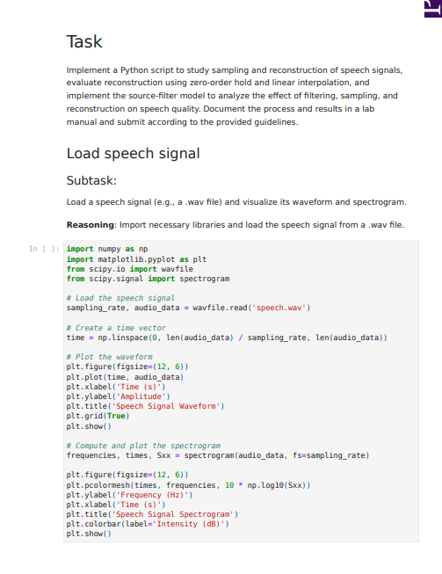

**Lab 2**

**Inference:**

This Python notebook analyses the frequency content of four different types of signals using the Fast Fourier Transform (FFT).

First, it generates and plots several basic signals in the time domain: a simple sine wave, a composite signal (two sine waves added together), a decaying exponential, and a rectangular pulse. For each of these, it then calculates and plots their frequency spectrum to show what "ingredients" (frequencies) they're made of.

The main point of the notebook is to demonstrate spectral leakage. This is a common issue in signal processing where the frequency analysis appears "blurry" because the signal is only observed for a short time. The final section clearly shows this problem using the composite signal and then demonstrates the solution: applying a Hamming window. The final plot compares the blurry spectrum with the much cleaner spectrum obtained after using the Hamming window.

**Lab 3**

**Inference:**

* Both models are highly accurate in quiet environments with clear speech.
* Whisper is far more robust, successfully handling background noise where Google's API fails.
* Whisper better understands fast or soft speech, preventing critical command errors.
* Google is better at formatting data (e.g., "five" to "5"), while Whisper excels at inferring grammar.
* Whisper is the more reliable choice for accessibility due to its superior performance in varied, real-world conditions.